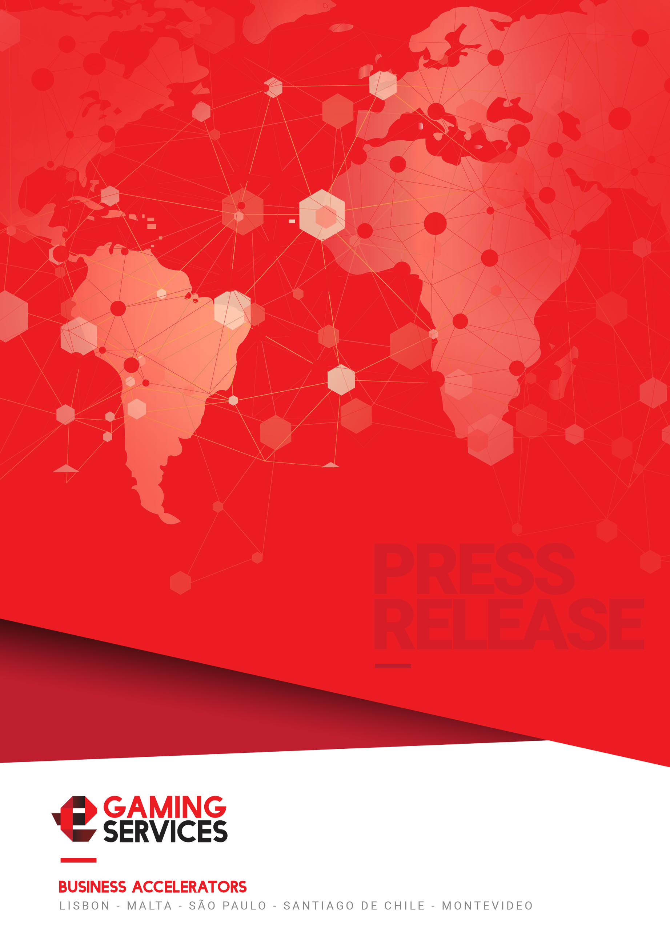
Tiago Almeida at the Caribbean Gaming Show & Summit: "We believe in Latin America as an essential region for operators"
The event opened on April 26 and 27

Lisbon, April 30th, 2018 - eGamingServices attended last week, as an exhibitor and official panellist, to the Caribbean Gaming Show & Summit, an important event in the Latin American market that brings together the largest and most important operators in the industry in the region.

This company, based in Portugal and with offices in Latin America, offered at its stand 31 its Strategic Consulting services to expand the activities of important European operators, bringing these brands to new markets to expand their income and mitigate related risks with the newly regulated markets in the continent.

During a conference about the opportunities in the Latin American market, Tiago Almeida, founder and CEO said: "We believe in Latin America as an essential region for operators. Profitability in LATAM is easy to achieve, with adequate understanding and cultural understanding. Also, the opportunities are there and the competition is still low. Latin America is one of the fastest growing e-commerce regions in the world, just behind Asia-Pacific. As a company that has clients in the sports betting and gambling business, we want to have a law that regulates our industry in the region. We believe that if the industry is reorganized it could reap benefits for all parties. "

Almeida had the opportunity to provide full coverage of Latin American markets, through an explanation of their situation, payment methods, popular products and leading operators. "Latin American markets require a lot of effort since the behaviour and preferences of the players are substantially different, with language skills that are difficult to find and specific preferences of niche products." He also emphasized the need to build bridges between the old continent (Europe) and emerging markets of great potential, putting as success stories some of the most important customers of the company that chairs.

Caribbean Gaming Show & Summit is an event that grows year after year, providing new business opportunities and bringing together all casino operators in the Caribbean. In addition, it has the participation of the most representative companies in the Mexican market. The event opened its doors in the city of Cancun, Mexico, on April 26 and 27.

To know more about the services offered by eGamingServices, visit our website at egamingservices.com

Contact Information
Stephanie Coccoluto Pestana - eGamingServices
Press Relations & Communication Manager
media@egamingservices.com/ s.coccoluto@egamingservices.com
http://www.egamingservices.com
+351 916 229 594
About eGamingServices
Founded in 2016 and based in the Portuguese city of Lisbon, eGamingServices also has offices in Brazil, Malta and Uruguay. The company helps gaming operators to redefine their product and find their customer online or within the retail channel of some of the regions with the most potential in the industry: Latin America, Europe and Africa. eGamingServices creates effective and efficient projects to help operators find new customers and generate more income.
For more information, please visit our site or follow us on Linkedin.

